PRACTICAL 2

**Part A**

**AIM:** Spinner, listener, <string-array>, layout.

**Scenario:** Create a single screen app with a spinner which should be populated with the image name from string resource. Implement a listener for the spinner for displaying the respective image below the spinner.

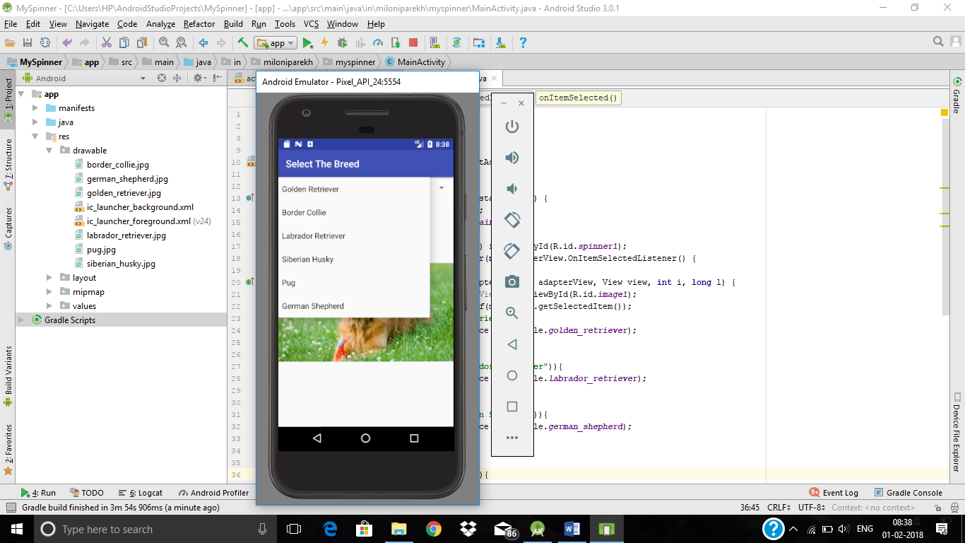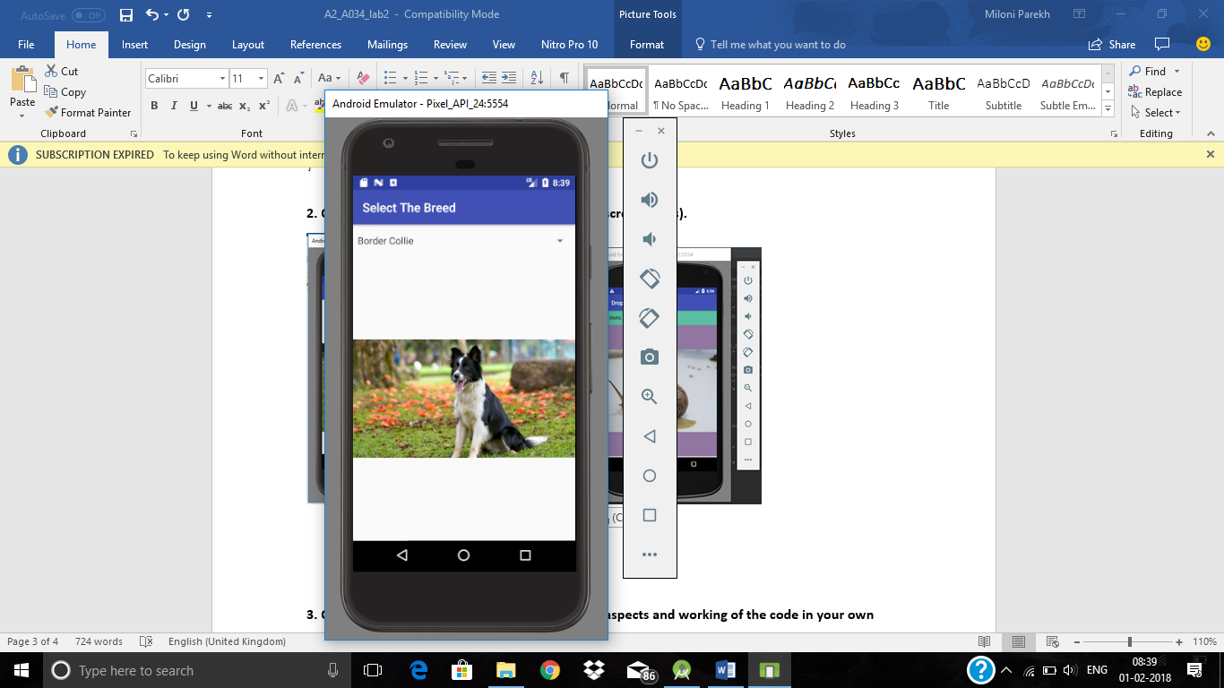

**Part B (to be completed by students)**

**(Students must submit the soft copy as per the following segments. The soft copy must be uploaded on the Blackboard. The filename should be Batch_RollNo_Exp_No)**

|  |  |
| --- | --- |
| **Roll No.: K005** | **Name: Jal Bafana** |
| **Prog/Yr/Sem: Btech cyber/2nd /Sem4** | **Batch: K1** |
| **Date of Experiment:22.01.2025** | **Date of Submission:22.01.2025** |

1. **Program Scenario and Program code:** (Write Scenario and Paste your program code (Java, xml resource and layout)).

<?xml version="1.0" encoding="utf-8"?>  
<RelativeLayout  
 xmlns:android="http://schemas.android.com/apk/res/android"  
 android:id="@+id/rel_lay"  
 xmlns:tools="http://schemas.android.com/tools"  
 android:layout_width="match_parent"  
 android:layout_height="match_parent"  
 tools:context=".MainActivity">  
  
<Spinner  
 android:layout_alignParentStart="true"  
 android:id="@+id/Spinner"  
 android:layout_width="match_parent"  
 android:entries="@array/photo"  
 android:layout_height="50dp"  
 />  
  
 <ImageView  
 android:layout_below="@id/Spinner"  
 android:id="@+id/imageView"  
 android:background="@color/black"  
 android:layout_width="fill_parent"  
 android:scaleType="fitXY"  
 android:layout_height="fill_parent"/>  
  
</RelativeLayout>

<resources>  
 <string name="app_name">K005_Spinner_Lab2</string>  
 <string-array name="photo">  
 <item>img1</item>  
 <item>img2</item>  
 <item>img3</item>  
 <item>img4</item>  
 <item>img5</item>  
 </string-array>  
</resources>

package com.example.k005_spinner_lab2;  
  
import android.os.Bundle;  
import android.view.View;  
import android.widget.AdapterView;  
import android.widget.ArrayAdapter;  
import android.widget.ImageView;  
import android.widget.Spinner;  
  
import androidx.appcompat.app.AppCompatActivity;  
  
public class MainActivity extends AppCompatActivity {  
  
 Spinner spnpic;  
 ImageView imgpic;  
  
 @Override  
 protected void onCreate(Bundle savedInstanceState) {  
 super.onCreate(savedInstanceState);  
 setContentView(R.layout.*activity_main*);  
  
 // Initialize Spinner and ImageView  
 spnpic = findViewById(R.id.*Spinner*);  
 imgpic = findViewById(R.id.*imageView*);  
  
 // Set up the Spinner with the array of items  
 ArrayAdapter<CharSequence> adapter = ArrayAdapter.*createFromResource*(this, R.array.*photo*, android.R.layout.*simple_spinner_item*);  
 adapter.setDropDownViewResource(android.R.layout.*simple_spinner_dropdown_item*);  
 spnpic.setAdapter(adapter);  
  
 // Set an OnItemSelectedListener to handle selection  
 spnpic.setOnItemSelectedListener(new AdapterView.OnItemSelectedListener() {  
 @Override  
 public void onItemSelected(AdapterView<?> parent, View view, int position, long id) {  
 // Get the selected item from the Spinner  
 String choice = String.*valueOf*(spnpic.getSelectedItem());  
  
 // Set image based on selected item  
 if (choice.equals("img1")) {  
 imgpic.setImageResource(R.drawable.*img1*);  
 } else if (choice.equals("img2")) {  
 imgpic.setImageResource(R.drawable.*img2*);  
 } else if (choice.equals("img3")) {  
 imgpic.setImageResource(R.drawable.*img3*);  
 } else if (choice.equals("img4")) {  
 imgpic.setImageResource(R.drawable.*img4*);  
 } else {  
 imgpic.setImageResource(R.drawable.*img5*); // Default case if no match  
 }  
 }  
  
 @Override  
 public void onNothingSelected(AdapterView<?> parentView) {  
 // Optionally, set a default image or leave blank  
 imgpic.setImageResource(R.drawable.*img5*); // Example default image  
 }  
 });  
 }  
}

1. **Output:** (Paste your program input and output screen shots).

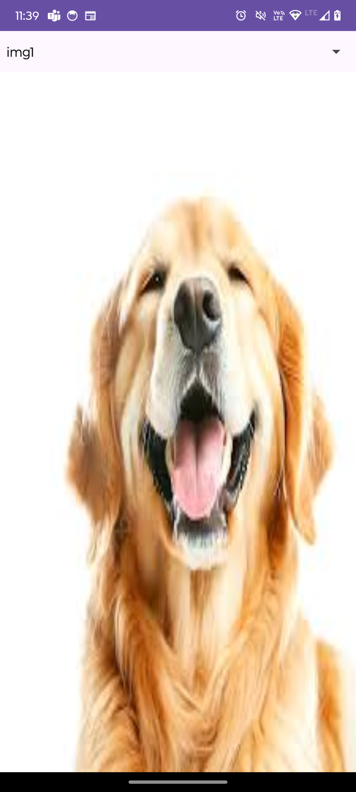

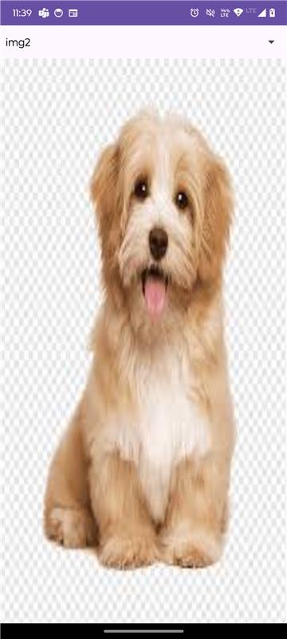





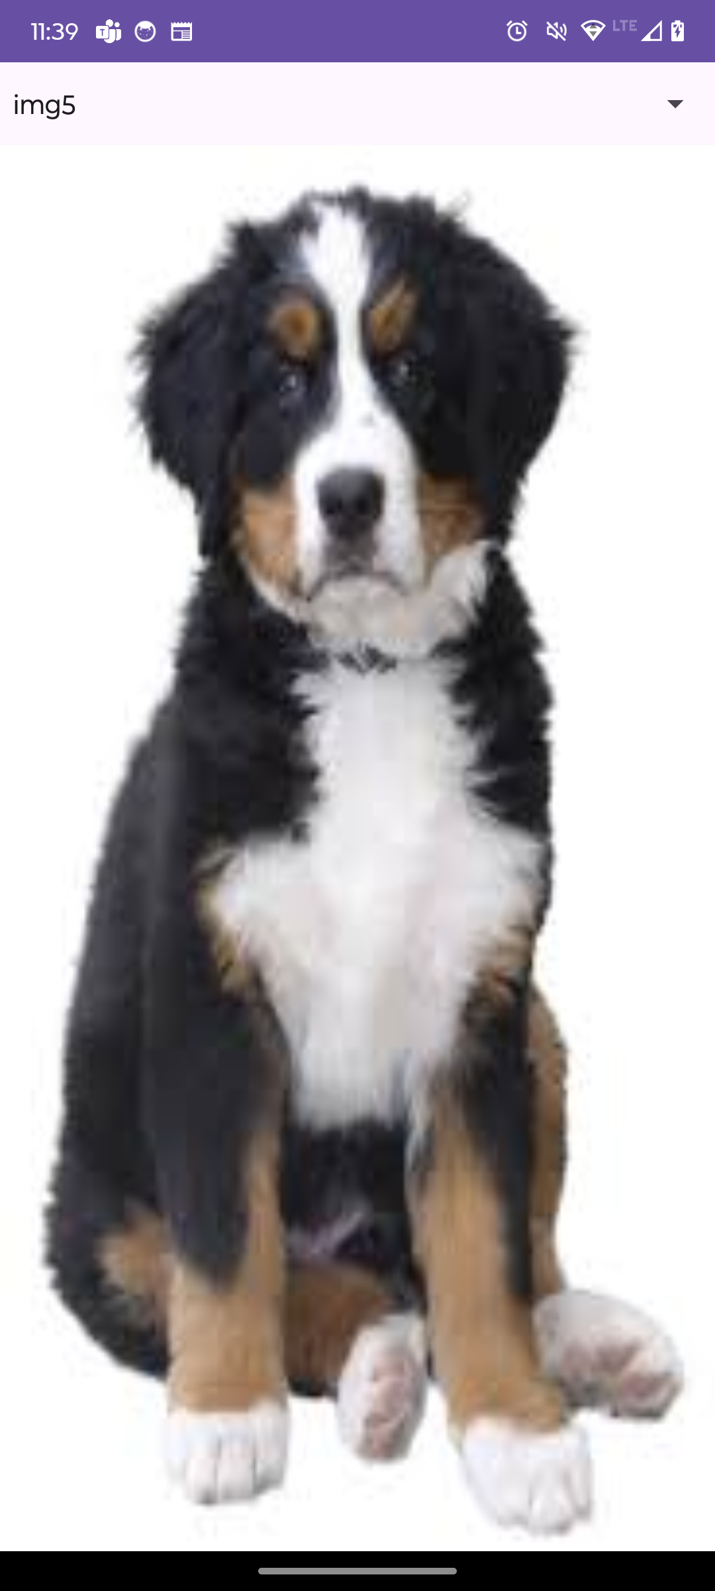

1. **Observations:** A brief description of the design aspects and working of the code in your own words.

The code allows the user to select an image from a Spinner, and the corresponding image is displayed in an ImageView. An ArrayAdapter is used to link the string items to the spinner, and an OnItemSelectedListener updates the image based on the selection.

1. **Questions: D**raw & Explain with respect to layouts the Scene Graph of the experiment.

Root Layout

├── Spinner (spnpic)

│ └── Item 1: "img1"

│ └── Item 2: "img2"

└── ImageView (imgpic)

1. **Conclusion (Learning Outcomes):** How were the outcomes defined for the experiment in Part A fulfilled through the scenarios.

The experiment teaches how to use a Spinner for user input and display corresponding images in an ImageView based on selection. It also highlights managing layouts, resources, and interaction handling in Android.